TDD Report
Geng Yuan，Mingjia Zou
Task1: Answer the following questions in your report:
- Screenshot of test coverage HTML report.
Execute the code in the corresponding directory:
pytest --cov=Task1_Rover --cov=Cipher --cov-branch --cov-report=html
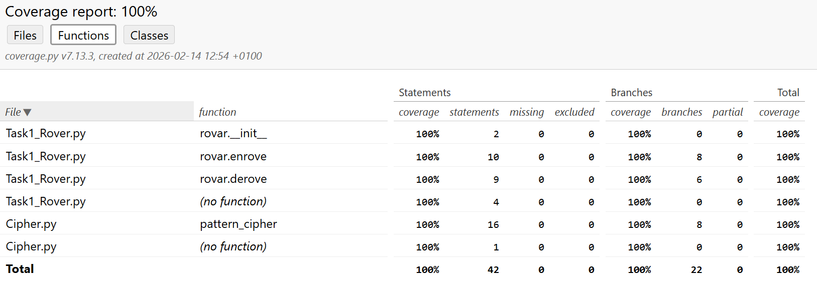
- What Types of coverage are measured?
- Statement Coverage
Statement coverage measures the percentage of executable code statements that have been run at least once during your tests.
- Branch Coverage
Branch coverage measures whether every possible path through a decision point has been taken.
- What was the Code coverage percentage achieved?
100%
- Describe the bug found in the code?
- The first bug:
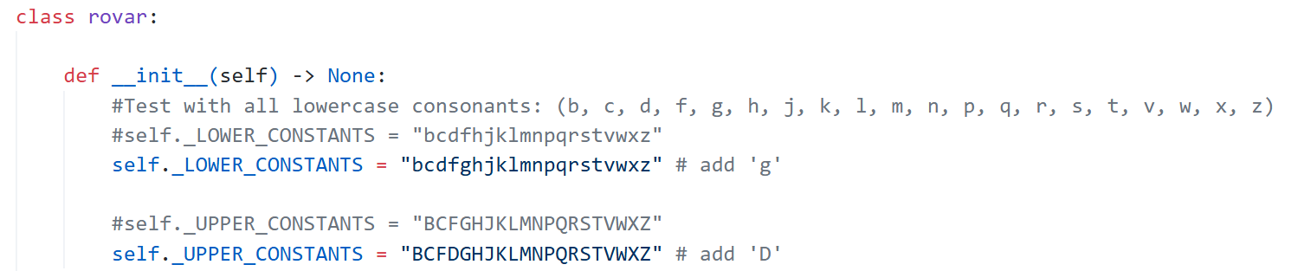
Missing Lowercase Consonant 'g' and Uppercase Consonant 'D'.
- The Second bug:
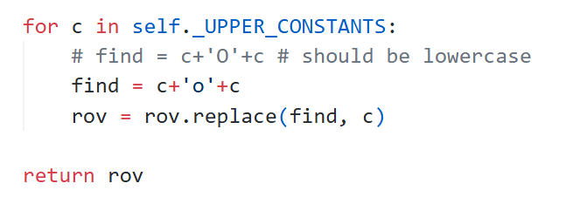
In the derove function, the code originally tried to find a pattern using an uppercase 'O', but it should have used a lowercase 'o' to match the encryption rules.
- Which test case(s) revealed the bug? (Copy-paste test case or screenshot)
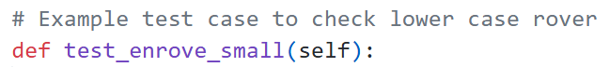

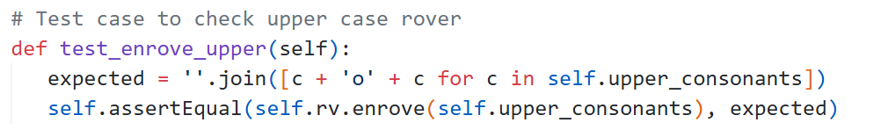
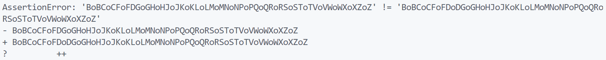

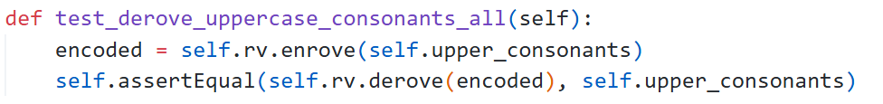
- How did you fix the bug?
As shown in the pictures of question 4.

Task2: Answer the following questions in your report:
- You should include a table mapping each test case to its equivalence class.
(ID) | Equivalence Class | Test Method | Input x | Expected | Rule
1 | Empty/None | test_none_input / test_empty_string | None, "" | None, "" | If the input is empty ("") or None, it is returned unchanged.
2 | Non-alphabetic | test_numbers_unchanged | "123", "#$3" | "123", "#$3" | - Only alphabetic words are transformed.  - Special characters/punctuation remain unchanged.
3 | Palindrome | test_palindrome_lowercase | "level", "civic" | "level", "civic" | If a word is a palindrome (reads the same forward and backward, case-insensitive), leave it unchanged.
4 | Repeated, Not Palindrome | test_repeated_letters_reverse | "hello", "letter" | "olleh","rettel" | If the word contains any repeated letters and is not a palindrome, reverse the word.
5 | All Unique Letters | test_unique_letters_rotate | "cat", "Python" | "atc", "ythonP" | - If all letters are unique, rotate the word left by one character.  - Original casing is preserved.
6 | Rule Priority | test_palindrome_priority_over_repeated | "noon" | "noon" | Some words may match multiple rules. Priority determines which rule is applied:  Palindrome > Repeated Letter > Unique Letter
7 | Single-Letter | test_single_letter | "a" | "a" | Rule 3
8 | Two-Letter | test_two_letter | "ab", "bb" | "ba", "bb" | Rule 5 / Rule 3
- Screenshot of test coverage HTML report.

- What Types of test coverages are measured?
- Statement Coverage.
- Branch Coverage.
- Equivalence Partitioning (EP) Coverage: palindrome, repeated letters, unique letters.
- What was the Code coverage percentage achieved?
100% for Statements and 100% for Branches.

